（英語）
布ナプキンの作り方
How to make a cloth sanitary napkin

Sanitary items are essential products for women. Until a sufficient amount of these products can be provided at evacuation shelters, you can make sanitary napkins by using absorbent cloth such as towel-cloth handkerchiefs, cotton underwears, or old cloth clothes.

- Prepare a cloth as big as handkerchief (20 to 25 cm)
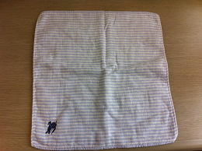

- Fold the cloth into thirds from the right and left sides.
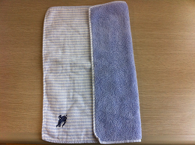

- Place it on the crotch area of your underwear.
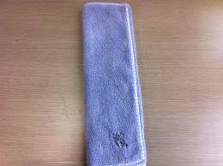

- If you cannot use water to clean it, you can reuse the cloth one more time by folding it the other way around.
