番号 | 見出し／本文 | 英語
50 | 布ナプキンの作り方 | How to make a cloth sanitary napkin
 | 女性にとって生理用品は必需品です。物資が十分に行き届くまでの間、タオルハンカチや綿の下着、古着など吸水性のある布を使って、ナプキンを簡単に作ることができます。 | Sanitary items are essential products for women. Until a sufficient amount of these products can be provided at evacuation shelters, you can make sanitary napkins by using absorbent cloth such as towel-cloth handkerchiefs, cotton underwears, or old cloth clothes.  - Prepare a cloth as big as handkerchief (20 to 25 cm)  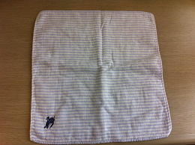  - Fold the cloth into thirds from the right and left sides.  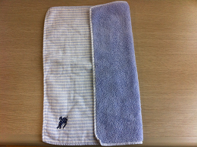  - Place it on the crotch area of your underwear.  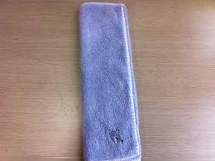  - If you cannot use water to clean it, you can reuse the cloth one more time by folding it the other way around.  