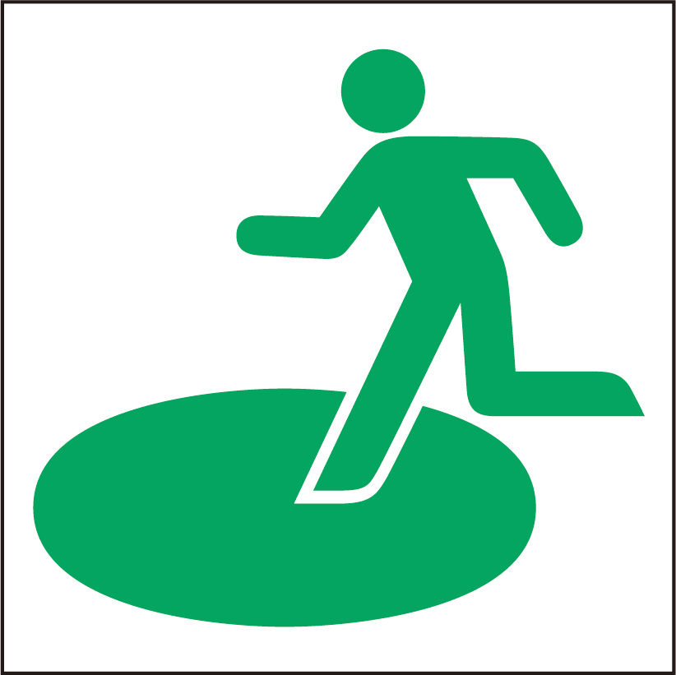
避難場所
にげる ばしょ
Evacuation Site

