Basic Information about the New Strain of Influenza A/H1N1

1 What is this new strain of influenza A/H1N1?
This new strain of influenza is the influenza virus A/H1N1 which originated in swine and has infected humans. The incubation period is usually 3~4 days (1~7 days also possible) and shows symptoms similar to those of conventional seasonal influenza such as fever, headache, cough, sore throat, runny nose and muscle pain. Symptoms related to the digestive system such as vomiting and diarrhea may also occur.
While most patients recover after suffering from mild symptoms only, there have been cases of people becoming seriously ill and even deaths have been caused by infection. It appears that people with underlying conditions such as asthma or other chronic respiratory diseases, heart disease, diabetes, or immunodeficiency, as well as pregnant women have a higher risk of developing serious symptoms if they become infected with A/H1N1 influenza.
The genetic sequence of the new strain of A/H1N1 which originated in swine is different from that of the A/H1N1 (Russian A-type) influenza, a conventional seasonal influenza that spreads among humans.

2 Cause and route of infection
The cause of this influenza is the A/H1N1 influenza virus which originated in swine.
The route of infection between humans of the A/H1N1 influenza virus that originated in swine is the same as other seasonal influenza viruses: “Droplet Infection” – breathing in the virus-infected droplets from coughing and sneezing by infected people, and “Contact Infection” – touching one’s mouth or nose with hands, etc. that have come into contact with the virus.

3 Treatment
The treatment of A/H1N1 influenza is the same as other seasonal influenzas. The main treatment is the administration of anti-viral drugs for influenza such as Oseltamivir (product name: Tamiflu) and Zanamivir (product name: Relenza). Treatment is administered in accordance with respiratory symptoms and overall body symptoms.

4 Prevention points
Prevention against infection by A/H1N1 influenza consists of 2 points: [Hand-washing & Gargling] and [Proper Etiquette When Coughing].

● Hand-washing and Gargling
Make a habit of washing your hands and gargling after you return home from being outdoors.
For the correct way to wash your hands, please refer to the attachment.
Hand-washing and gargling are the basics of personal hygiene. Make a habit of washing your hands and gargling when you return home after being outdoors. Wash your hands if you have used them to cover your mouth or nose when coughing or sneezing.
If you cannot wash your hands with running water, using an alcohol type cleanser which can wash and disinfect the fingers is also useful. However, if there is visible dirt on your hands, the disinfecting effect will be inadequate. In such a situation, wash your hands with running water and soap.

● Proper etiquette when coughing
If you cough or sneeze, cover your mouth and nose with a tissue or mask. Try not to allow cough and sneeze droplets to come into direct contact with others.
- If you have symptoms of coughing or sneezing, wear a mask
- Cover your mouth and nose with a tissue when you cough or sneeze

5 Receiving medical examinations and consultation for A/H1N1 influenza
Medical examinations for A/H1N1 influenza can be received at all general hospitals, clinics, etc. in (自治体名). To prevent the spread of infection, you should contact a hospital or clinic by telephone in advance to be informed of the time and method of examination. You should wear a mask when you go for examination.
After diagnosis, basically most people will recuperate at home, however, for people with underlying diseases or depending on the health of the person etc. admission to a hospital for treatment may be required.

● Medical examinations for pregnant women and people with underlying diseases
At present it is not known if pregnant women are more susceptible to being infected with A/H1N1 influenza or if it has any effect on the unborn child. When pregnant women become infected with conventional seasonal influenza most show typical influenza symptoms, however, some also develop pneumonia and other complications and there is a possibility of premature birth.
Besides following general infection prevention habits of washing hands, etc, it is important to pay close attention to changes in your health condition. If a pregnant woman has symptoms such as a temperature, cough, sore throat, etc, she should contact her obstetrician and ask to be introduced to a hospital or clinic where she can have a check-up and be treated.
People who have underlying diseases, such as those who are receiving treatment for respiratory diseases, heart diseases, diabetes, those who are receiving renal dialysis or those who show signs of immunodeficiency, should contact their family doctor in advance to confirm how they can receive a medical examination for A/H1N1 influenza.

People who do not have a family doctor or a doctor they receive treatment from regularly, or do not know which medical facility they can receive a medical examination for A/H1N1 influenza, or are being treated at home should consult a “Shingata Influenza Sodan Center”.

6 A/H1N1 influenza patients and their families
A/H1N1 influenza is different from conventional seasonal influenza in that most people do not have any immunity to it. Because of this, it is important to act in a way that will prevent the spread of the virus.
In order to prevent A/H1N1 influenza from spreading, infected people should refrain, as much as possible, from being in places where people gather for at least 2 days after their temperature has fallen or 7 days from the day after they began experiencing symptoms such as a sore throat, etc.

● To people infected with A/H1N1 influenza
1. Take medication as prescribed by the doctor
2. Except for medical examinations, avoid going outdoors during the period instructed by the doctor or health office
3. Wear a mask and be careful when coughing etc. when you go for a medical examination or are receiving care at home etc.
4. Wash your hands as often as possible

● To family members
If the patient shows any of the following symptoms, telephone a medical facility and have them receive a medical examination. If you call an ambulance, inform them of the influenza symptoms.
- Breathing difficulties
- Purple lips
- Complaints of chest pain
- Possibility of dehydration
Continuous vomiting and inability to consume adequate fluids / amount of urine is small / baby cries without tears
- Convulsions are noticed
- Unusual confusion or excitement is noticed
- The patient’s response is slow or dull when they are called, etc.

● Points to note when taking care of infected people
1. Wash hands thoroughly and repeatedly
2. Wear a mask when taking care of the patient
3. Dispose of tissues and masks used by the patient in vinyl bags.
4. Place the patient in a room separate from other people
(If this is not possible, the person resting or sleeping in the same room should be more than 1m from the patient.)
5. Limit the people who take care of the patient
(If possible, people with a heart disease, diabetes or other underlying disease, pregnant women, or people with low immunity should not take care of patients)
6. Open the windows of the patient’s room a few times a day to air the room
(When airing the room, keep the door to the patient’s room shut)
7. Use paper towels or personal-use towels to dry your hands after washing them
8. Keep the house/apartment clean (see below)

● Cleaning / disinfecting the house/apartment
See below for how to clean the patient’s room and items they have used.

Cleaning the patient’s room and items they have used
Place /Item | Cleaning method
floor | Wipe with a damp mop or floor cloth
door knob, toilet seat,  switches, handrails  tables, chairs, etc. | Wipe with disinfectant (as below)
dishes / clothes / sheets / bathtub, etc. | Cleaning and washing as per normal

Types of disinfection and methods of use

Any of the following methods may be used to disinfect the patient’s room, clothing or items which the patient’s blood, excrement, bodily fluids (excluding sweat) may have become attached to. Spraying disinfectant is not recommended because it may displace the viral germs into the air with insufficient disinfecting effect, thus also endanger the caretaker who may breathe in the scattered viral germs.

When the caretaker is cleaning or disinfecting the room, etc. they should wear gloves, mask, and goggles to protect their eyes.
ethanol disinfectant | Clean the items by wiping them with a paper towel, etc. soaked with ‘ethanol disinfectant’ which can be purchased at a pharmacy
sodium hypochlorite | Soak a paper towel with diluted chlorine based bleach and clean the items by wiping them. (See below for how to dilute the bleach)
disinfecting  with hot water | Disinfect clothes and dishes in water of 80 degrees Celsius or more  for more than 10 minutes

Material: Ministry of Health, Labor and Welfare, “A/H1N1 Influenza Positive Epidemiology Investigation Summary”

[For reference: How to dilute chlorine base bleach]

(Bleach sold over the counter: When the chlorine level is approx. 5%)
0.02% --- For disinfecting clothes and cleaning items
0.1% --- For cleaning vomit, excrement, body fluids (blood, etc.)

(Note) Since sodium hypochlorite corrodes metals, wipe metal parts with a wet cloth after about 10 minutes. Also, since chlorine gas may be emitted, ensure that the area is well ventilated.
Concentration  (level of dilution) | Method of dilution
0.02%（200ppm） | Add 10ml to a 2 liter PET bottle of water  (10ml = 2 PET bottle capfuls)
0.1%（1000ppm） | Add 10ml to a 500ml PET bottle of water  (10ml = 2 PET bottle capfuls)

Create lather with soap and wash your hands as shown below.
Before washing
Wash Your Hands Regularly
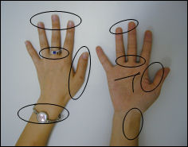 | Places where dirt easily remains
◆Are your nails cut short?  ◆Have you removed your rings and watch?   | Places where dirt easily remains | ◆Finger tips  ◆Between fingers  ◆Around the thumb  ◆Wrist  ◆Wrinkles on your hand

(1) After creating a lather with the soap,  thoroughly wash the palms of your hands | (2) Wash the back of your hands
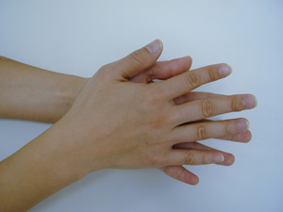 | 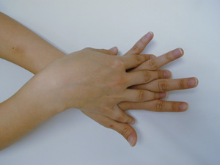
(3) Carefully wash your finger tips and around  your nails | (4) Wash between your fingers
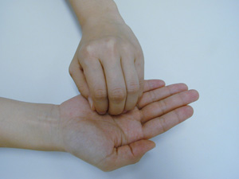 | 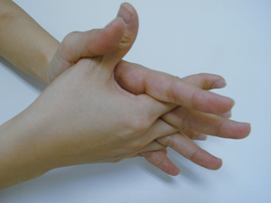
(5) Wash your thumbs in a twisting action  as below | (6) Don’t forget to wash your wrists
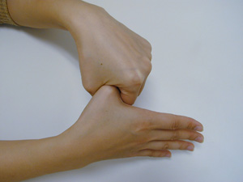 | 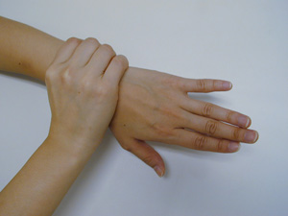
Rinse the soap off with running water and dry your hands with a clean towel

