(1) Individual Number mailing will begin in October!
- The “My Number” Individual Number system is about to begin in Japan.
- The Individual Numbers, each one unique to its holder, are important because they are required for procedures at municipal offices, etc.
- From October 2015 on, your municipality will mail an envelope to your residence (at the address registered therewith).
- The envelope contains a “Notification Card” with your Individual Number on it.
[Notification Card]
[Envelope]
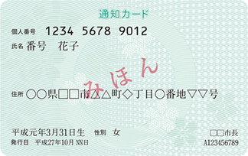
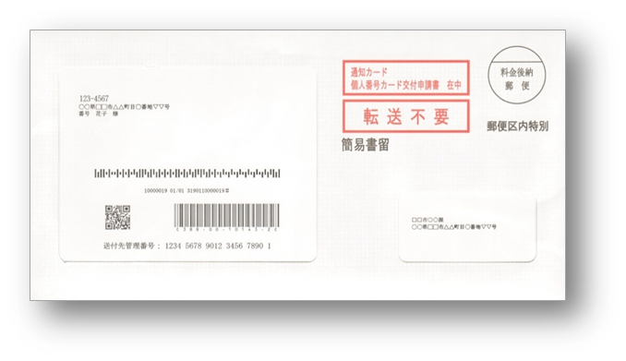
(Front)

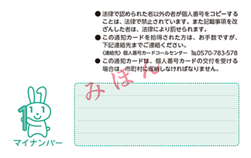
(Back)

(2) Handle your Individual Number with care!
- Keep your Notification Card at hand and be careful not to throw it away or tear it.
- To avoid illegitimate use of your Individual Number, do not tell it to others except as required.
(3) “Individual Number Cards” will be available!
- Your “Individual Number Card” also serves as an ID card bearing your Individual Number.
- In some municipalities, convenient options like having convenience stores issue residence certificates are available.
- To apply for an “Individual Number Card”, fill in and send back the application provided with the “Notification Card.”
[Application]
[Individual Number Card]
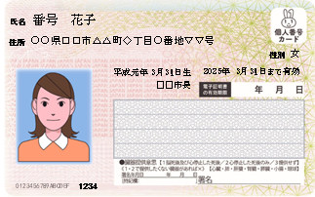
(Back)
(Front)
(Front)
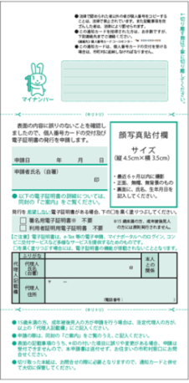
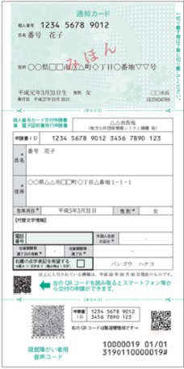

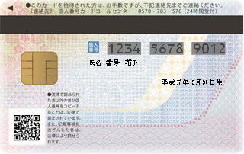
(Back)

(4) If you have any questions
- Go to the site below, or call the number below. You can also contact the municipal office of the town where you live (your municipality).
・Web site
http://www.cas.go.jp/jp/seisaku/bangoseido/index.html
・Call center
0570-20-0291 (English / Chinese / Korean / Spanish / Portuguese)
[Until 30 September 2015]
Monday – Friday 9:30 – 17:30 (not available on weekends or holidays)
[From 1 October 2015 through 31 March 2016]
Monday – Friday 9:30 – 20:00 Weekends/holidays 9:30 – 17:30
(Not available during the New Year’s holiday)
*Call charges will apply because these are Navi-Dial services.

